Name:

Lab 7: Stream network and stream hydrology

- (1 pt.) Refer the drainage diagram below to complete the table.

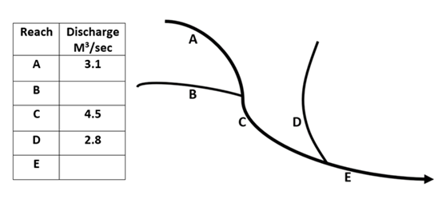

River discharge (the volumetric flow rate of a river) is a critical metric in hydrologic monitoring. It is typically expressed as Q= VA, where Q is discharge, V is velocity, and A is cross-sectional area. Since river channels almost never have a constant depth in a given cross section, many depth and velocity measurements are typically taken across the channel to yield an accurate discharge measurement. Depths are then averaged and multiplied by the channel width for A, and velocity readings are averaged for V.

- (1 pt.) Determine the discharge of the hypothetical river channel cross section below, given the measurements provided. Please show your calculations.

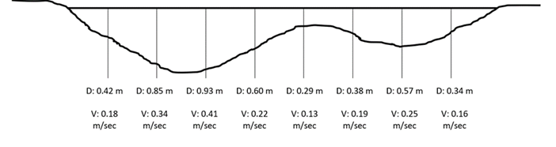
Channel width= 6.10 meters
Discharge: ________m³/sec

- (1 pt.) Discharge is the volume of water flowing past a given river cross section per unit time and can be expressed by the following formula: Q (Discharge) = Area x Velocity
We often approximate area with rectangles, so the above formula goes to Q = Width x Depth x Velocity. What happens to velocity if the cross-sectional area of the river decreases but the discharge stays constant?

- (1 pt.) Consider the following scenario: There are two river channels, channel A and channel B, that have identical cross-sections, and both are filled to the top of their banks with water. Channel A has as steeper slope than Channel B. Fill in the blanks below with A or B.
The water in channel ______ is moving faster than the water in channel _______.
The discharge in channel _____ is greater than the discharge in channel ______.

- Examine Figure 1 shown below. As you can see from these figures, the velocity of the water in a channel is not the same everywhere in a cross-section. Although the absolute magnitudes of the velocity may be different for different discharges and in different channels, the general pattern of velocity shown in these figures is found in all channels for all discharges.
Why is the velocity slowest near the channel boundaries? (1pt)

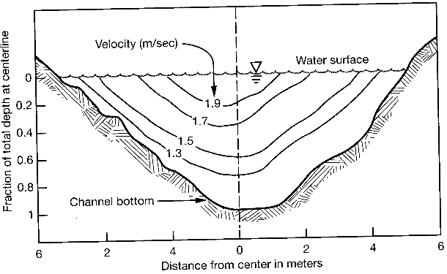
Figure 1: Contour map of velocity at a cross section
- Refer to Figure 2: Do you think the velocity measured at point A is the same as at point B? Why or why not? (1pt)

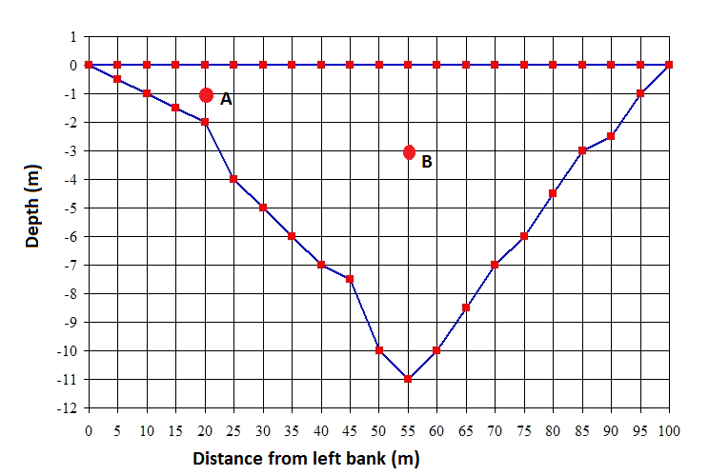
Figure 2: schematic of a river cross-section
- Examine Figure 3 shown below and answer the following questions (2 pts.)

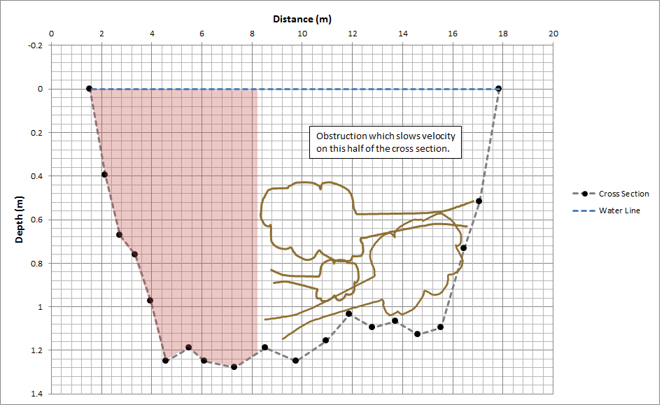
Figure 3: Channel cross section with obstruction

  - If a tree falls into the river and blocks one part of the cross section, slowing velocities in that part of the channel, what might happen to the velocity in the pink-shaded region of the flow (remember that in this scenario Q must be held constant because no water has been added or taken away)?

  - Again considering the discharge equation, is there a different response that you think might make sense?

  - If flow velocity increases, what do you think might happen to sediment on the bed and channel banks?

  - Is sediment likely to be eroded or deposited in the unshaded half of the cross section? Why?

Download the .kml file “Lab Assignment 7” from Canvas to answer the following questions.

- (2 pt.) Sinuosity is a measure of how “curvy” something is. It is a metric commonly applied to river systems, expressed as S_{i}= Channel Length/ Valley Length (A completely straight river would have a sinuosity value of 1). Using the ruler tool (using ‘path’) in Google Earth, determine the channel length and the valley length. First determine the sinuosity of the section between point 1 and point 2. Then do the same for the section between point 3 and point 4.

- Sinuosity (between points 1 and 2): ________
- Sinuosity (between points 3 and 4): _________
- Notice that the channel suddenly straightens (between points 3 and 4). The channel was channelized to allow for more efficient flow of water for irrigation purposes. What do you think channelizing (i.e. straightening) a channel does to the slope of the river?

